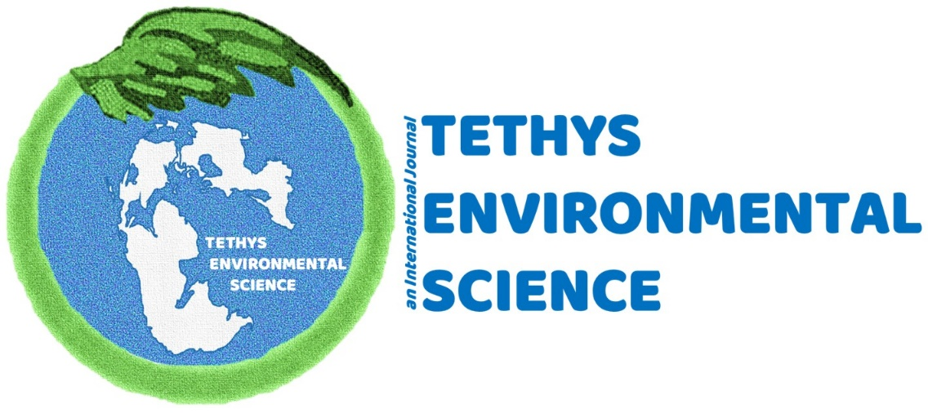
ETHİCAL PRİNCİPLES AND PUBLİCATİON POLİCY
ETHICAL GUIDELINES
Tethys Environmental Science (Tethys Env. Sci.) is an international peer-reviewed scientific journal. Ethics issues and policies for authors, referees, editor and the Publisher have been prepared based on open access guides and policies of the Committee on Publication Ethics (COPE; (https://publicationethics.org/).
Manuscripts submitted to Tethys Environmental Science are evaluated by double-blind review process. Accepted papers are published electronically and free of charge. The following summarizes the ethical guidelines and policies for authors, referees and editors.
ETHICAL GUIDELINES FOR AUTHORS
• Manuscripts submitted to Tethys Environmental Science should be original work and authors are expected not to submit their work to other journals. The copy right transfer form should be signed by the corresponding author and submitted along with the manuscript.
• Only authors with significant contribution should be listed as co-authors.
• Authors should declare conflict of interest in connection with the manuscript.
• Authors, if required, should provide meta data and other details about their study to the editor
• All Literature used in the main text should be cited in references.
• When the authors detect a major error or inaccuracy, they should communicate with the editor and explain the nature of the error. Depending on the nature of the error, the manuscript can be corrected or retracted.
• For studies that require ethics committee decision, authors should declare that they received approval from ethics committee. The name of the ethics committee along with approval date and number should be indicated on the materials section of the manuscript. A copy of the original approval form must also be submitted online.
• If the manuscript contains previously published contents such as pictures, figures or tables, the author should provide a statement of permission to reproduce the material from the copyright owner. The authors will be held responsible for any legal and financial liabilities.
ETHICAL GUIDELINES FOR REVIEWERS
• Reviewers should ensure that reviewing process is confidential and adhere with the bilateral blind review and should not contact the authors.
• The manuscript should be within reviewer’s area of expertise.
• If reviewers discover a conflict of interest they should recuse themselves from the review process and contact the editor.
• Reviewers should phrase their comments appropriately and with due respect.
• Reviewers should be fair, unbiased in their assessment of the manuscript.
• Reviewers should complete the review process within a reasonable time and should not unnecessarily prolong the review process.

ETHICAL GUIDELINES FOR EDITORS
The editör-in-chief, the associated editor and the field editors of Tethys Environmental Science follow ethics guidelines by "COPE Code of Conduct and Best Practice Guidelines for Journal Editors" and "COPE Best Practice Guidelines for Journal Editors" as described below.
- General duties and responsibilities
• The editor is responsible for all the manuscripts published in Tethys Environmental Science. He is responsible for the peer review prceses, originality of manuscrios, ethic committe and experimental permissons, and copy right issues. He is also responsible for improving the journal policy and enable the implementation of journal policy.
• Editor is responsible for improving the quality of the journal.

- Relation with authors
• Resposible fort he decision making proceses by tking into consideration the originality and impotance of the manıscript, its relevance to the journal’s scope and, the validty and reliability of experimental methods.
• If the submitted manuscript is rejected after preliminary reviewing he should Notify the authors for his decision and provide detailed explanation.
• Provide informstion to the authors about the status of the manuscript without breaching the double sided blind review process.
• Should review and update instructions for authors
3. Relation with reviewers
•Select reviewers based on their expertise in connection with the manuscript.
• Contact reviewers to reveal any conflict of interest for an unbiased review of the submitted manuscript.
• Make sure the reviewing process is confidential and the double-sided blind review process is not breached.
• Encourage reviewers to conduct an unbiased review and to phrase their comments respectfully
• Maintain a data base of reviewers, update this list on the bases of performance and seek to enlarge the reviewer pool.
• Remove from the JMSF list of any reviewers who consistently produce biased reviews and does not follow ethical guidelines and seek to investigate if a reviewer misconduct is suspected.
4. Relations with editorial board
• Maintain regular contact with the members of the editorial board for the best practice of journal management and inform the members about the journal policies.
• Evaluate the members of the editorial board and seek to identify and select members who actively contribute to the development of the journal.
• Assign manuscripts to the members of the editorial board on the bases of their expertise
ETHIC RESPONSIBILITIES OF THE PUBLISHER
• Editors-in-chief should have full authority over the content of the journal. All decisions made by Editors-in-chief should be independent of the Publisher/owner.
• The publisher should provide open access to the journal’s content free of charge.

PLAGIARISM AND ETHICAL ISSUES
Manuscripts that are submitted to our journal are meticoulsly examined for plagiarism and ethical issues. The following are taken into consideration during this process.
Plagiarism
Plagiarism is the unattributed use of another author’s work. Plagiarism may take different forms; for example, while literal copying or substantial copying is considered plagiarism, paraphrasing the work of another author is also considered as plagiarism. In order to prevent potential plagiarism problems, manuscripts submitted to Tethys Environmental Science are screened for similarity using IThenticate (http://www.ithenticate.com/) software. Manuscripts with a similarity index of 30% or less will be accepted for further reviewing. Manuscripts with higher similarity than 30% are examined in detail and, if necessariy, sent back to authors for review and correction. Manuscripts are rejected when plagiarism is detected.
Non original work
Non original work arises when non-existent or manipulated data are used in scientific studies. When necessary, the editor may require further information with regard to when, where and how the study was carried out. This information is important for originality of the work.
Authorship of contribution
Our journal requires that, although the concept of authorship is defined vaguely, contributions by all authors should clearly be defined and non-contributors or those with trivial contributions should not be conferred the status of author. In addition, all contributors should approve the final draft of the manuscript. In essence, an author should also be able to defend the paper. When necessary, the editor, may ask all authors.
Redundant Publication
Redundant publication or double publication refers to publishing the same manuscript more than once. It is very important that manuscripts submitted to our journal should be original work and should not have been submitted to other journals. In addition, data slicing that involves segmentation of a single study into multiple publications should be avoided.
The following summarizes other important unethical issues in submitting manuscripts to our journal:
• Not indicating whether the manuscript is produced from the author’s Masters/PhD thesis or a project.
• Using someone’s unpublished material without permission of the author.
• Breaching ethical rules in experiments involving humans or animals.
• Not considering animal welfare, biological diversity and habitat conservation
• Conducting experiments involving animals without appropriate authorization or permission.
In addition to above mentioned issues, authors are expected to declare conflict of interest in connection with the manuscript, for unbiased reviewing.

